AIM: To perform frame works of various operation on home page search page and different pages work on it

CODE:

Code for home page java class

package com.ninja.qa.Pages;

import org.openqa.selenium.WebDriver;

import org.openqa.selenium.WebElement;

import org.openqa.selenium.interactions.Actions;

import org.openqa.selenium.support.FindBy;

import org.openqa.selenium.support.PageFactory;

import com.ninja.qa.Base.TestBase;

public class HomePage extends TestBase {

Actions a = new Actions(driver);

@FindBy(xpath = "//span[text()='My Account']")

WebElement myaccount;

@FindBy(xpath = "//a[text()='Register']")

WebElement register;

@FindBy(xpath="//a[text()='Login']")

WebElement login;

@FindBy(xpath="//a[text()='Desktops']")

WebElement desktop;

@FindBy(linkText ="Mac (1)")

WebElement macdropdown;

public HomePage(WebDriver driver) {

PageFactory.initElements(driver, this);

}

public void gettitle()

{

String title = driver.getTitle();

System.out.println(title);

}

public void clickonMyAccount()

{

myaccount.click();

}

public void clickonLogin()

{

login.click();

}

public void clickonRegister()

{

register.click();

}

public void clickOnMac() throws InterruptedException

{

a.moveToElement(desktop).build().perform();

Thread.sleep(1500);

macdropdown.click();

}

}

Code for home page test

package com.ninja.qa.TestPages;

import org.testng.annotations.AfterMethod;

import org.testng.annotations.BeforeMethod;

import org.testng.annotations.Listeners;

import org.testng.annotations.Test;

import com.ninja.qa.Base.TestBase;

import com.ninja.qa.Pages.HomePage;

public class HomePageTest extends TestBase{

HomePage hp;

@BeforeMethod

public void OpenApp()

{

openBrowser();

hp = new HomePage(driver);

}

@AfterMethod

public void CloseApp()

{

driver.quit();

}

@Test(priority='1')

public void testTitle()

{

hp.gettitle();

}

@Test(priority='2')

public void testRegisterLink()

{

hp.clickonMyAccount();

hp.clickonRegister();

hp.gettitle();

}

@Test(priority='3')

public void testLoginLink()

{

hp.clickonMyAccount();

hp.clickonLogin();

hp.gettitle();

}

@Test(priority='4')

public void testMacLink() throws InterruptedException

{

hp.clickOnMac();

hp.gettitle();

}

}

OUTPUT:

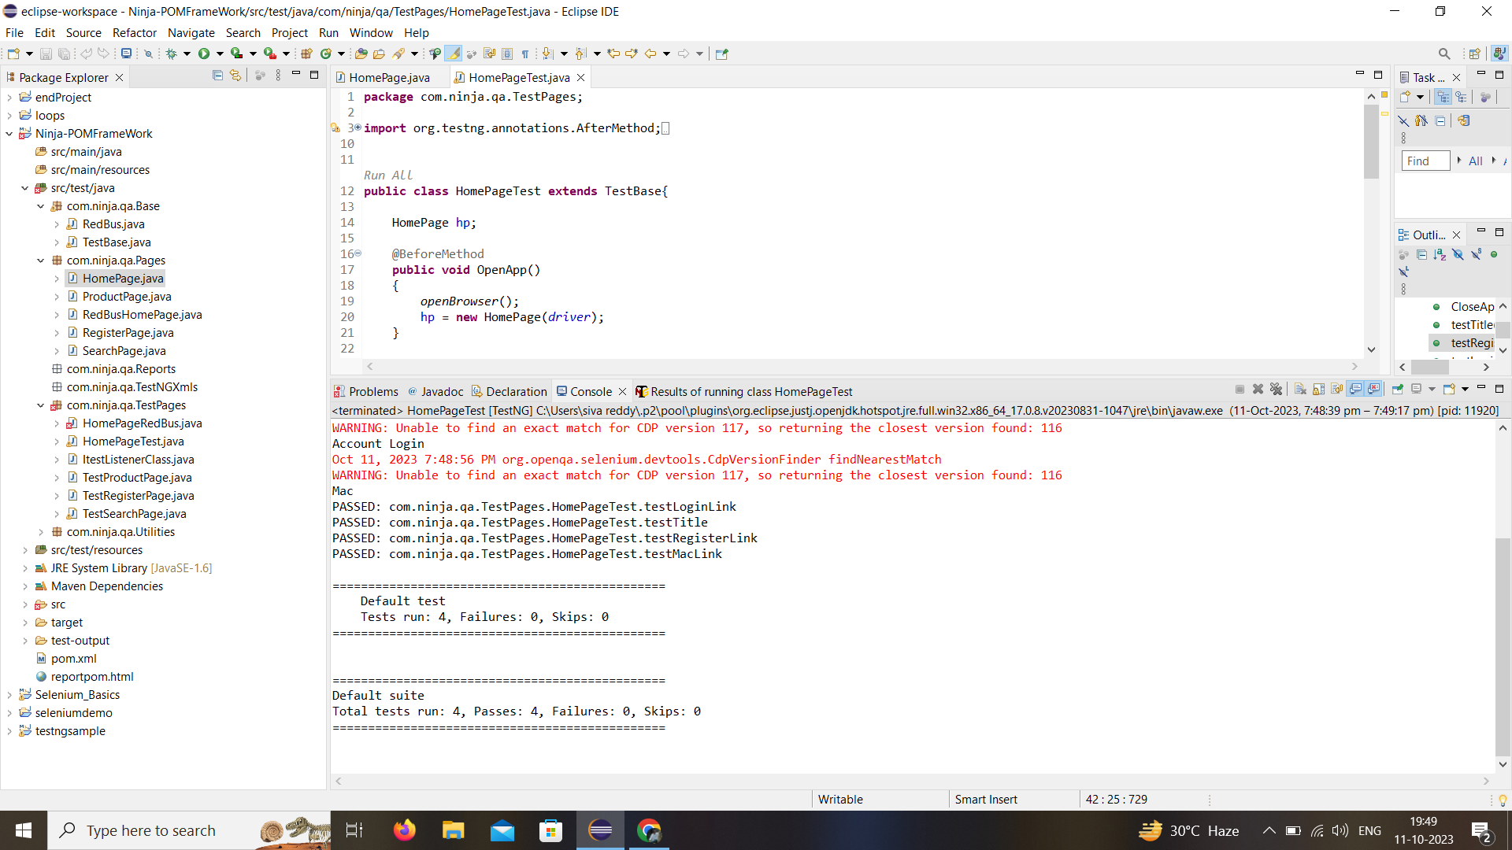

Code for product page in java class

package com.ninja.qa.Pages;

import org.openqa.selenium.WebDriver;

import org.openqa.selenium.WebElement;

import org.openqa.selenium.support.FindBy;

import org.openqa.selenium.support.PageFactory;

public class ProductPage {

@FindBy(xpath="//input[@id='input-quantity']")

WebElement quantity;

@FindBy(xpath="//button[@id='button-cart']")

WebElement addtoCart;

public ProductPage(WebDriver driver) {

PageFactory.initElements(driver, this);

}

public void addtocart() throws InterruptedException

{

quantity.clear();

quantity.sendKeys("5");

Thread.sleep(1000);

addtoCart.click();

}

}

Code for product page in test class

package com.ninja.qa.TestPages;

import org.testng.annotations.AfterMethod;

import org.testng.annotations.BeforeMethod;

import org.testng.annotations.Test;

import com.ninja.qa.Base.TestBase;

import com.ninja.qa.Pages.ProductPage;

import com.ninja.qa.Pages.SearchPage;

public class TestProductPage extends TestBase{

SearchPage sp;

ProductPage pp;

@BeforeMethod

public void OpenApp()

{

openBrowser();

sp = new SearchPage(driver);

pp = new ProductPage(driver);

}

@AfterMethod

public void CloseApp()

{

driver.quit();

}

@Test

public void testproduct_addtocart() throws InterruptedException

{

sp.searchproduct();

Thread.sleep(1000);

sp.selectproduct();

Thread.sleep(1000);

pp.addtocart();

}

}

OUTPUT:

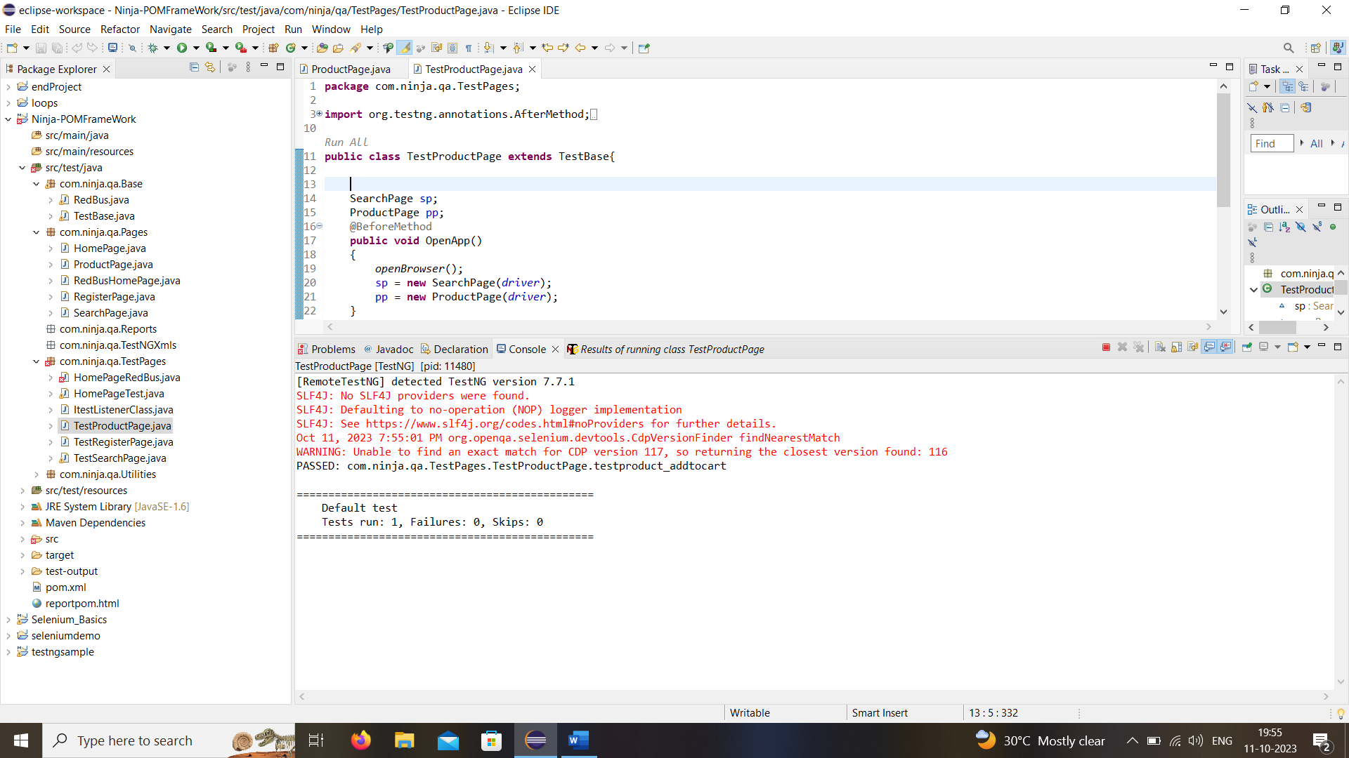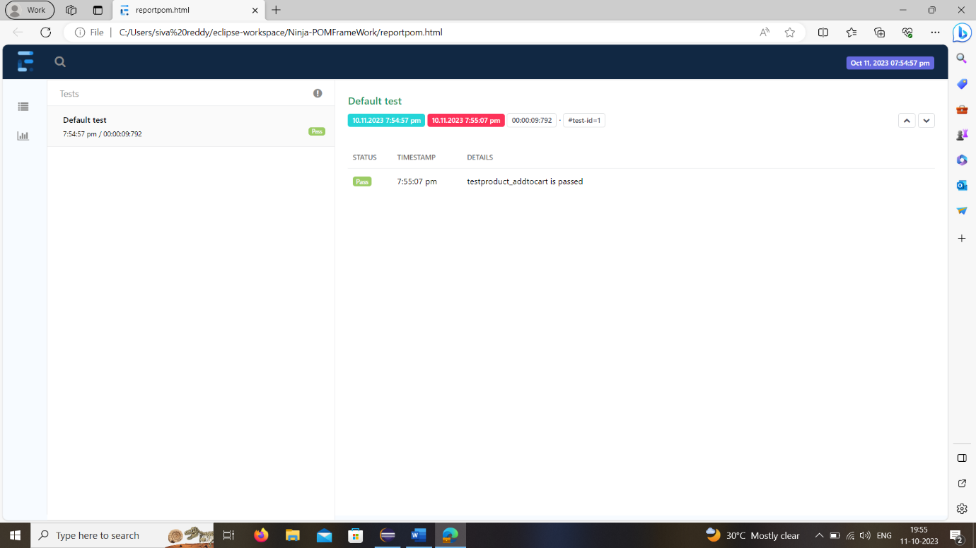

Code for search class

package com.ninja.qa.Pages;

import org.openqa.selenium.WebDriver;

import org.openqa.selenium.WebElement;

import org.openqa.selenium.support.FindBy;

import org.openqa.selenium.support.PageFactory;

public class SearchPage {

@FindBy(xpath="//input[@name='search']")

WebElement searchbox;

@FindBy(xpath="//button[@class='btn btn-default btn-lg']")

WebElement searchboxbtn;

@FindBy(linkText="iMac")

WebElement product;

public SearchPage(WebDriver driver) {

PageFactory.initElements(driver, this);

}

public void searchproduct()

{

searchbox.sendKeys("mac");

searchboxbtn.click();

}

public void selectproduct()

{

product.click();

}

}

Code for search test class

package com.ninja.qa.TestPages;

import org.testng.annotations.AfterMethod;

import org.testng.annotations.BeforeMethod;

import org.testng.annotations.Test;

import com.ninja.qa.Base.TestBase;

import com.ninja.qa.Pages.HomePage;

import com.ninja.qa.Pages.RegisterPage;

import com.ninja.qa.Pages.SearchPage;

public class TestSearchPage extends TestBase {

SearchPage sp;

@BeforeMethod

public void OpenApp()

{

openBrowser();

sp = new SearchPage(driver);

}

@AfterMethod

public void CloseApp()

{

driver.quit();

}

@Test

public void searchProduct() throws InterruptedException

{

sp.searchproduct();

Thread.sleep(1000);

sp.selectproduct();

}

}

OUTPUT:

